**The Minister mentioned: The development of digitization, network and intellectualization of manufacturing industry is an irreversible trend.**

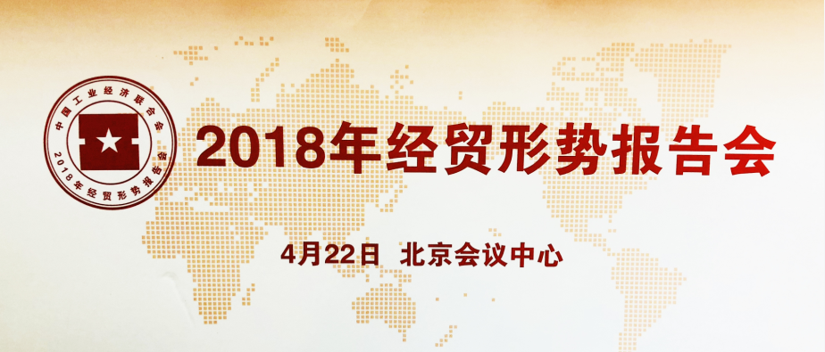

On April 22, 2018, “The economic and trade situation report meeting 2018", sponsored by China federation of industry economics, was held at the Beijing convention center. MS. Yiyang Fan, the President of Kangshuo Group and CEO of IM Chain, was invited to attend the meeting as a representative of the China intelligent manufacturing industry association.

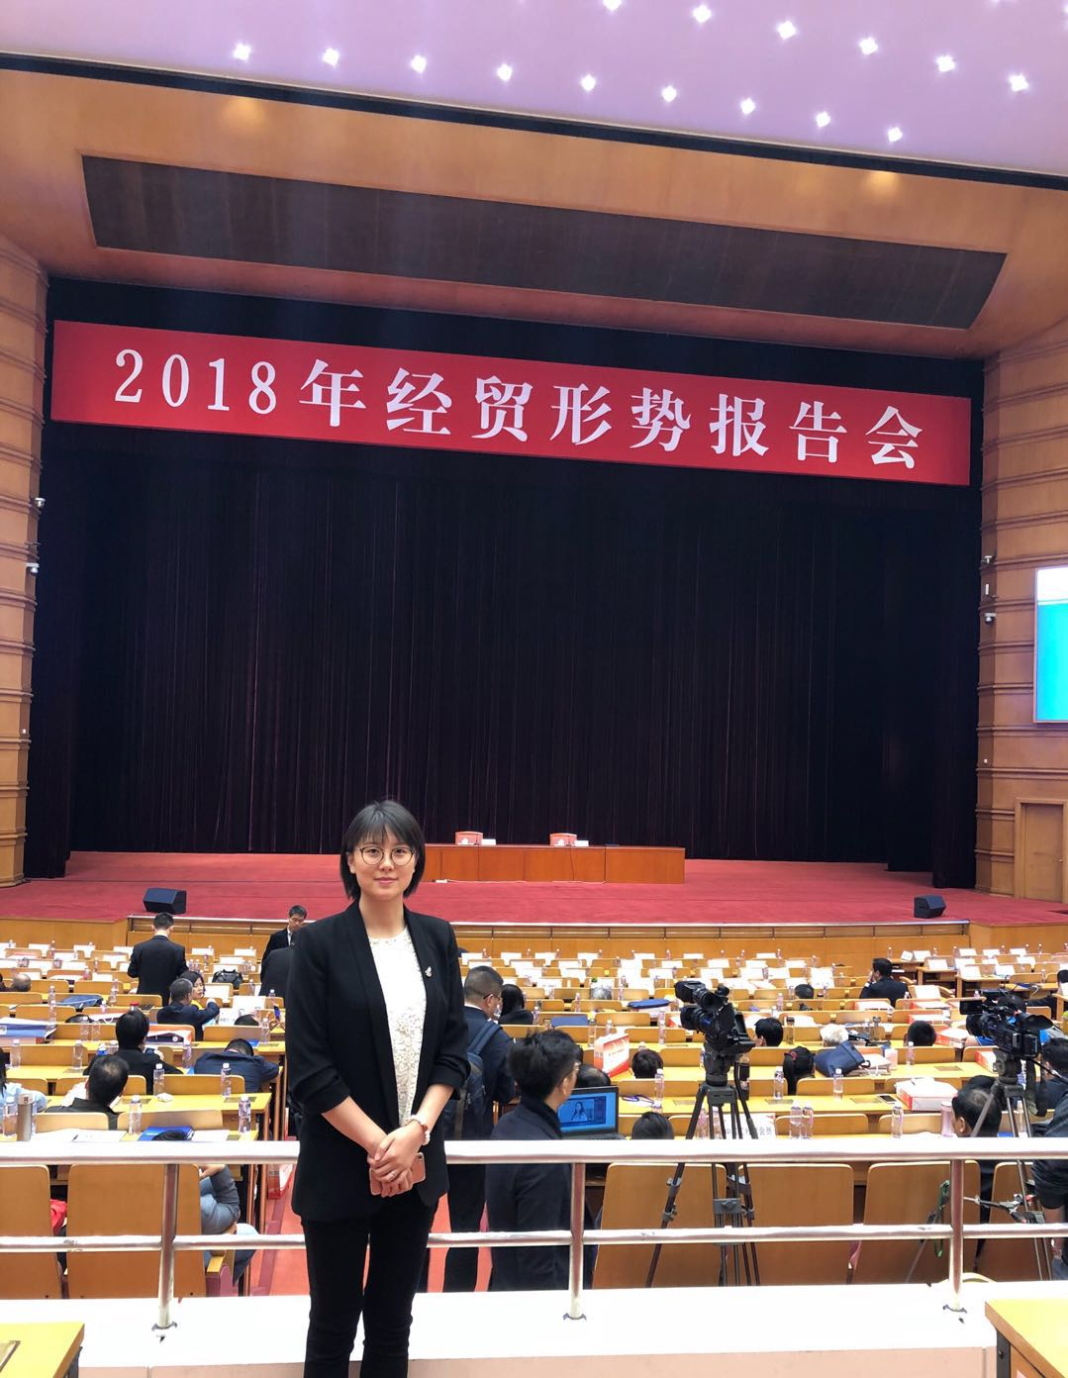

（President of Kangshuo Group and CEO of IM Chain MS. Yiyang Fan）

Kang Shuo group is committed to promoting the ecological development of 3D printing industry, has been formed a set of high accuracy, industrial-grade 3D printing services, research and development, sales, application development for the integration of industry leading enterprises, the services has been widely used military-industrial complex, aerospace, automotive, medical and cultural creativity industries, etc.

In the report meeting, Miao Wei, Minister of the Ministry of Industry and Information Technology, Wang Zhigang, Minister of the Ministry of Science and Technology, Liu Wei, Deputy Minister of Finance, and Shi Zihai, Deputy Secretary-General of the National Development and Reform Commission, provided an informative and forward-looking work report for the participants. It is worth mentioning that the reports of the leaders of the participating countries all pointed out that it is necessary to insist on scientific and technological innovation as the leading factor and promote the development of the manufacturing industry in the direction of digitization, networking, and intelligence. The imperative is to superimpose China's manufacturing advantages with networking and intelligence to form new supply capacity in the digital age. Network intelligence affixes new labels to traditional manufacturing industries, promotes the rapid development of subversive production methods such as personalized customization, flexible supply, and collaborative manufacturing, accelerates the integration of intelligent manufacturing technologies, and expands new areas and growth points from traditional manufacturing.

The Intelligent Manufacturing Chain (IM Chain) that the Kangshuo Group is fully involved in is in line with the direction of industrial development pointed out by ministers. Based on intelligent manufacturing and block chain technology, the intelligent manufacturing chain platform provides a groundbreaking M2D (Manufacturing to Demand manufacturing to demand) business model, matching fragmentation public demand with discrete manufacturing capabilities, and facilitating the connection of manufacturing capabilities. Promote the transition from product-centered manufacturing to demand-centered manufacturing, and at the same time make up for the huge market gap in the existing e-commerce sector that cannot provide customized manufacturing products.

It is believed that the Intelligent Manufacturing Chain will gradually lead intelligent manufacturing to everyone’s life and promote the prosperity and development of made in China 2025. IM Chain may the creation be with you!